AGILE DEVELOPMENT PROCESS AND
DEVOPS LAB

LAB FAT EXAM

NAME : MADHUMITHA.K.R
REG NO : 23MIS0132
SLOT:L3+L4
COURSE CODE : ISWE406P
FACULTY:DR.BALAGANESH

QUESTION :
Set 4
Payment processing system
Problem statement:
Ensure payment are processed securely and correctly
Tasks
1.develop payment validation logic
2.junit testing for transaction success /failure
3.implement CI/CD pipeline with automated testing
Setup version control using github
Configure CI pipeline to tigger on code commits
Integrate automated unit tests in pipeline
Configure CD pipeline for automated unit test in pipeline

4.deploy kubernets and docker
Containzers application using docker
Build and push docker image to container registry
Create kubernets deployment and service yaml files

Step 1: Java Program Execution :

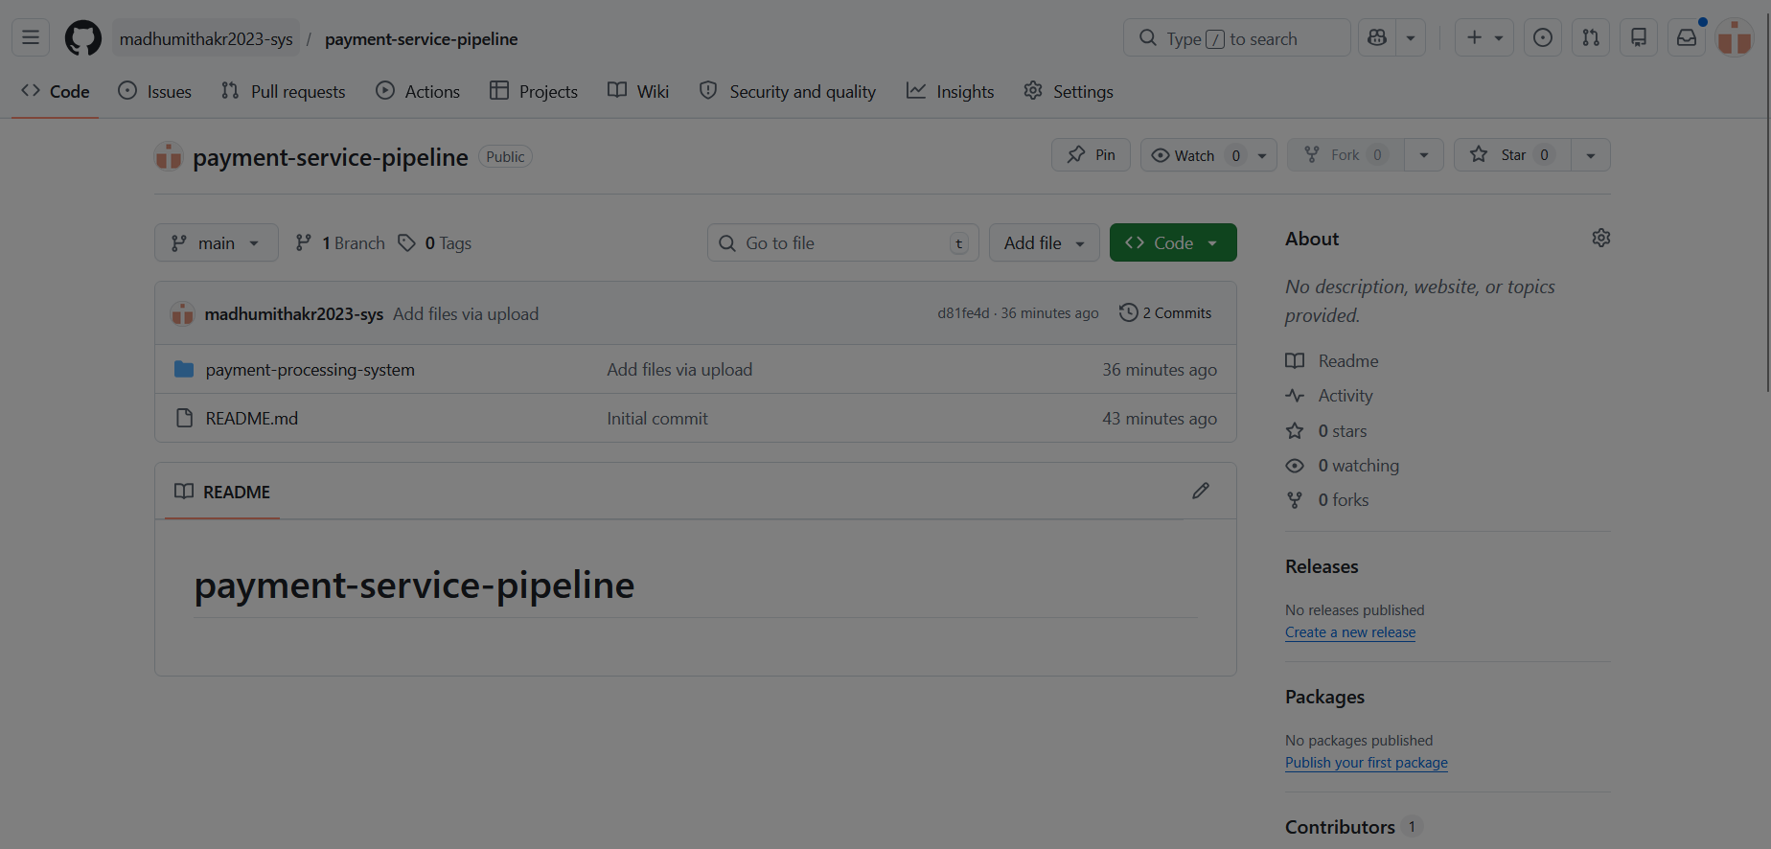
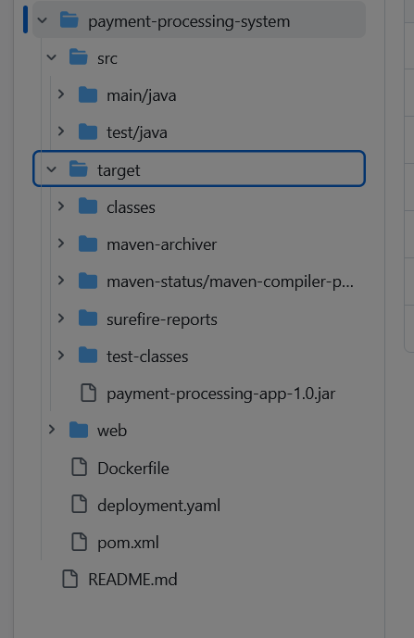
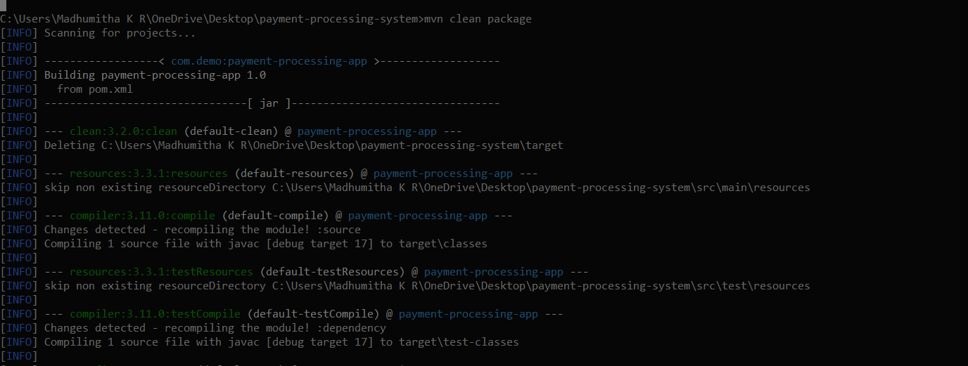
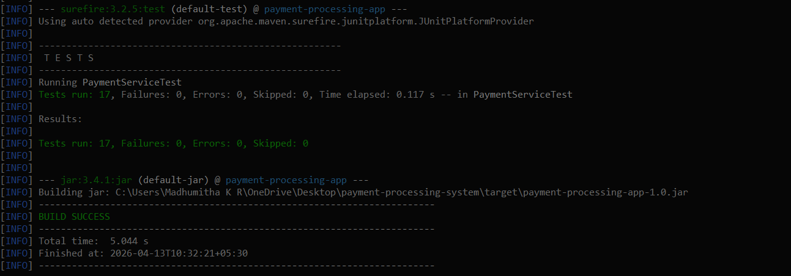

[Website UI]
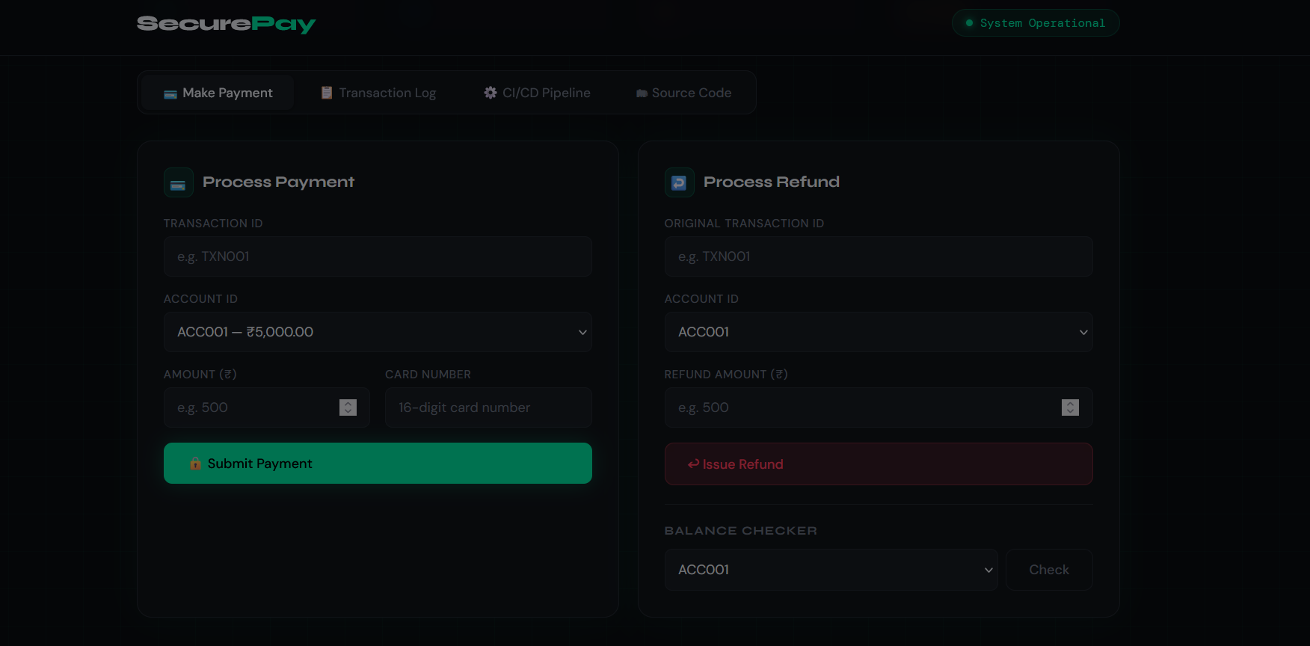
Step 2: JUnit Testing
Pom.xml file

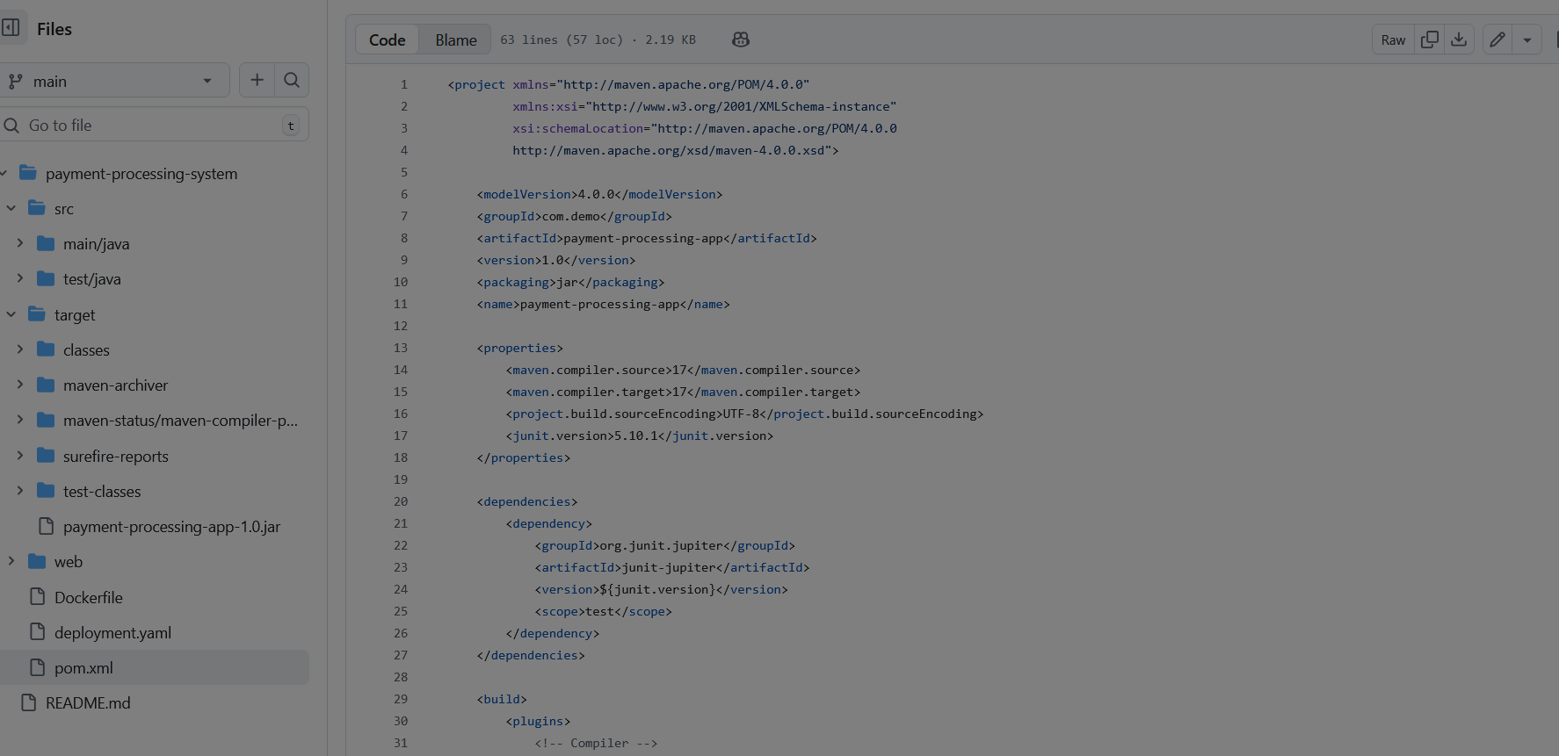

Java test file:
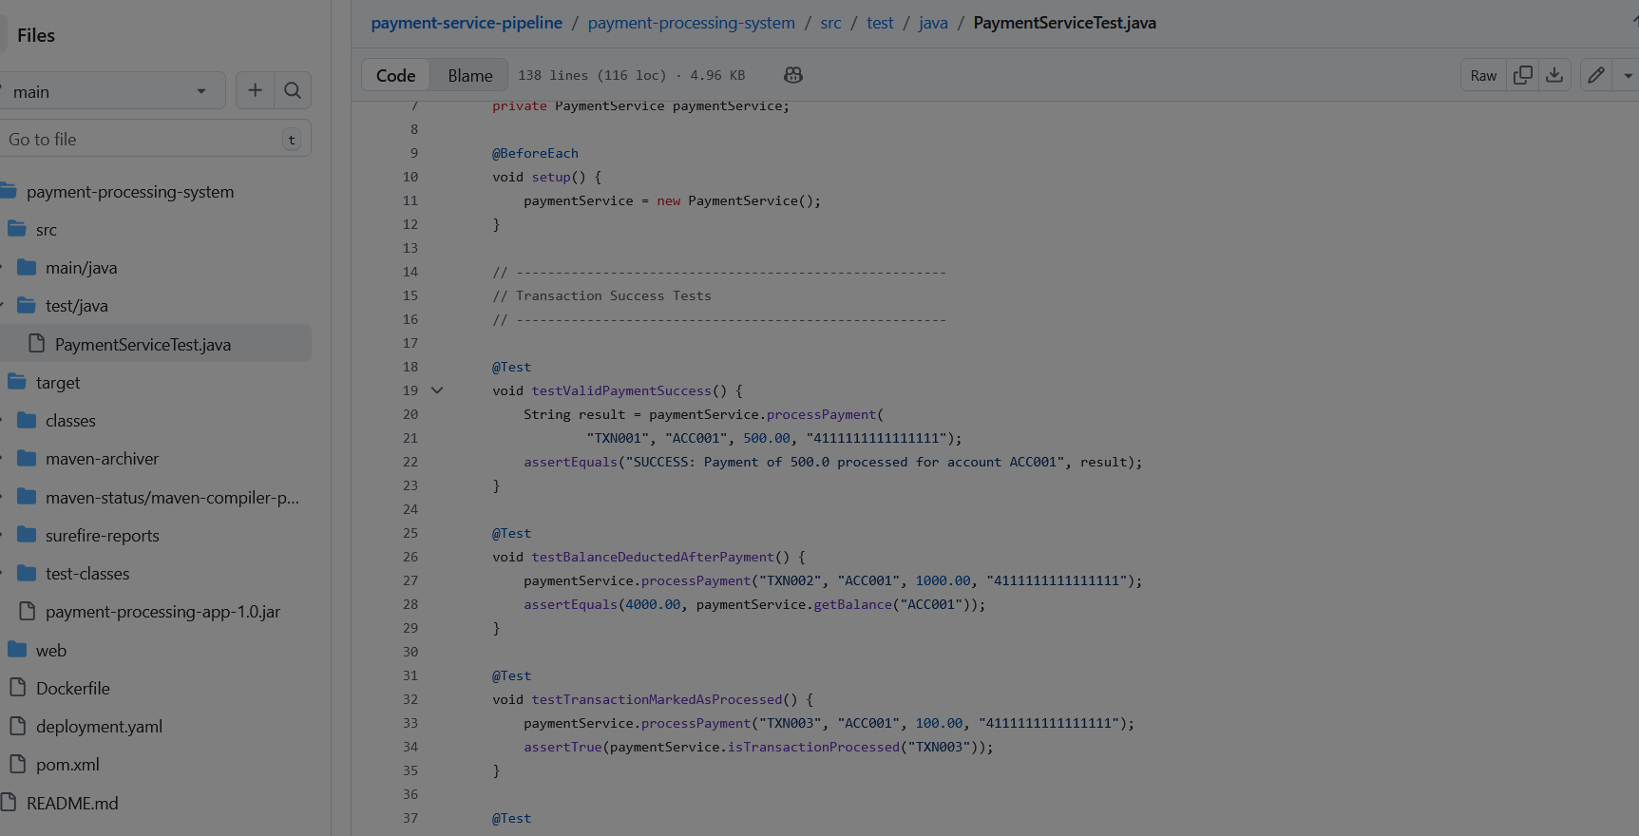

Step 3: CI/CD Pipeline

